The capacitive button matrix makes use of the change in capacitance if one of the ‘buttons’ is pressed. Between the layers of (conductive) fabric is a layer of foam. Capacitance is determined by the distance between the conductive layers.

The sofware ‘autotunes’ by tracking a long term average and reacting on changes in the momentary capacitance.

Based on https://www.circuitbasics.com/how-to-make-an-arduino-capacitance-meter/

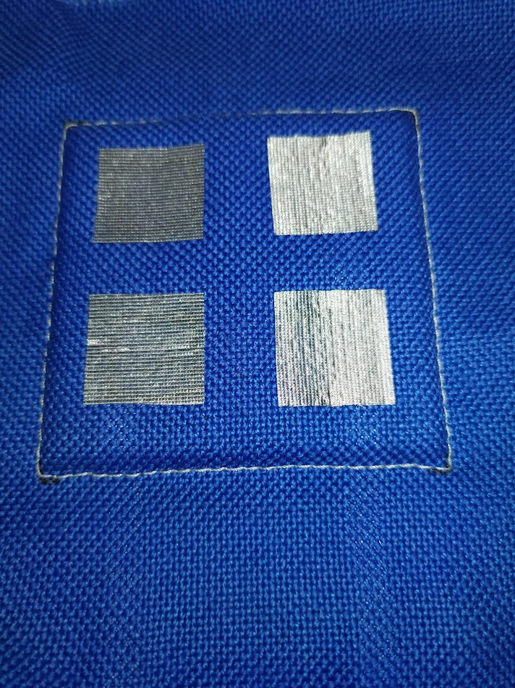

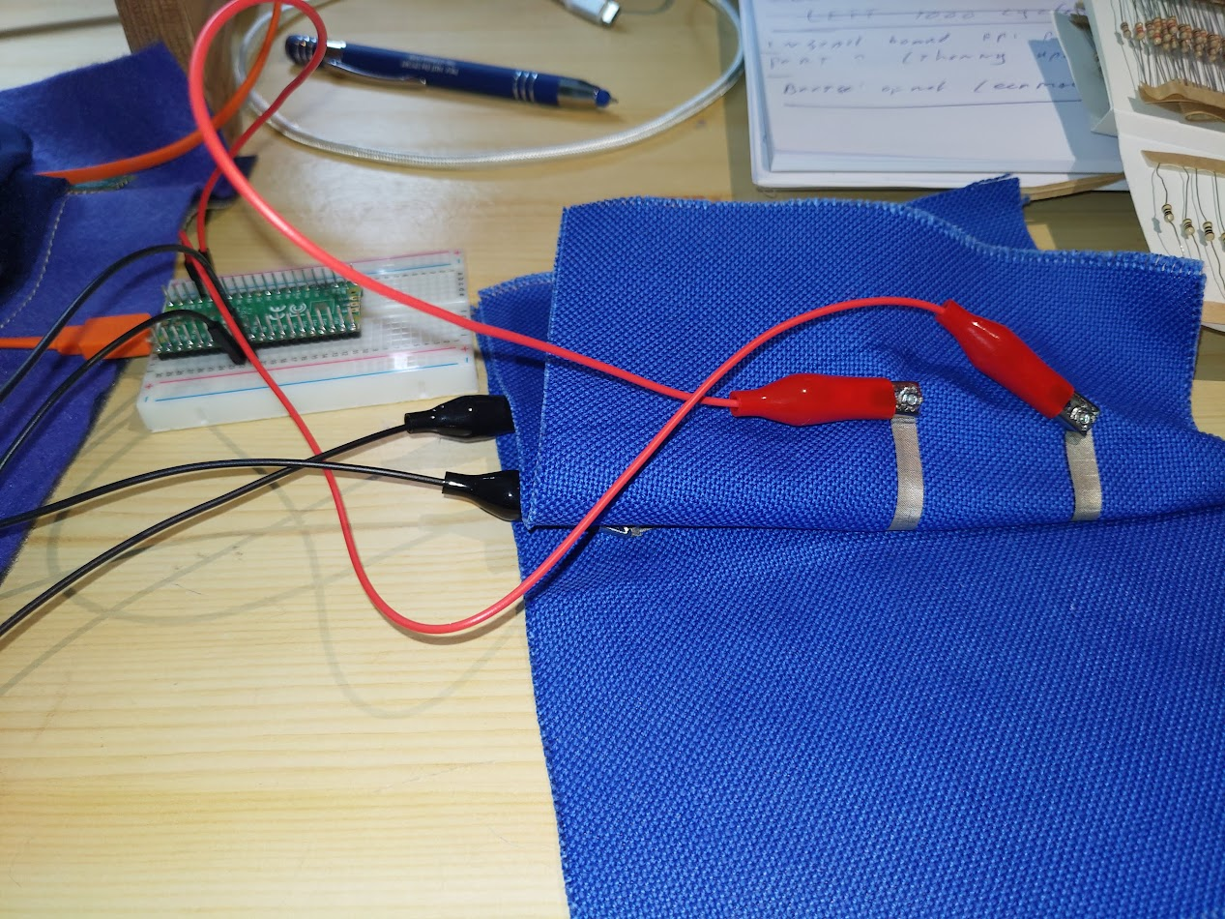

A way to connect the buttons. Drive pins red, sense pins black

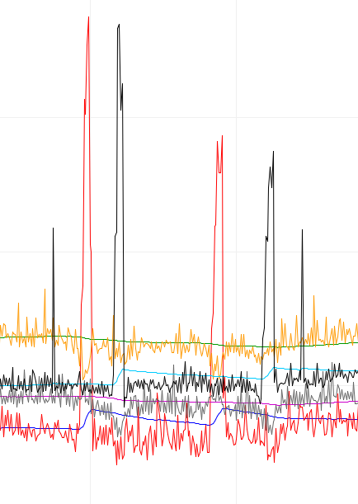

Shape of the resulting signal.   
The small black peaks are not (real) touches: some extra filtrering may be needed.